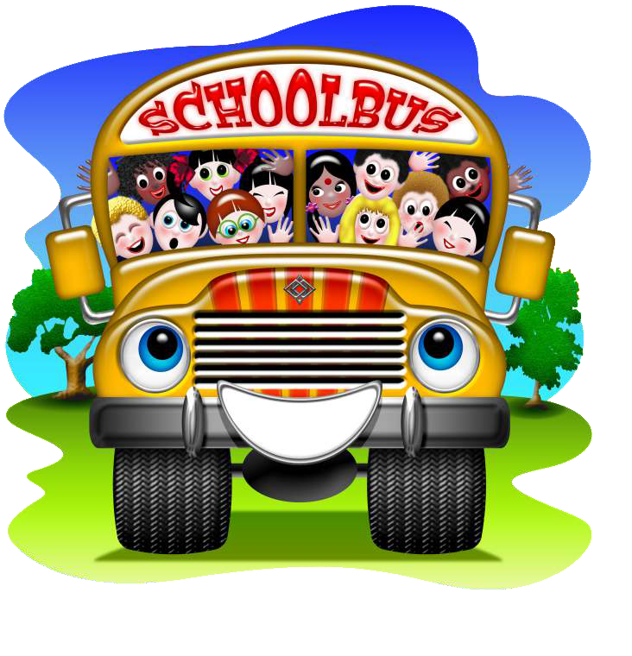 |  | Waratah All Year Care  - Erskine Newsletter September-October 2019

Our job is child’s play

Do you have permanent bookings? You will have a Storypark account

Information for families
Waratah would lie to remind all children and families that children must bring their own hat and drink bottle everyday they are in care.
Quality Improvement Plan
3.2.3 Resources support play based learning
The outdoor area was damaged after the last school holidays. The grass was bald in patches and branches of trees were broken. For the children’s safety and for the protection of the play areas, we are looking at revising how we sue the outdoor area
Community Event
The wearable art exhibition is on until the 22nd of September. Head down to the performing arts centre to see the amazing pieces our local artists have created.
Our reflections and focus
After child and family feedback we have decided to promote teeth brushing amongst our little creatures’ program.
Fun Fact
History and prehistory are marked by the invention of records. Anything before written record is ‘prehistory’ any records are in ‘history’
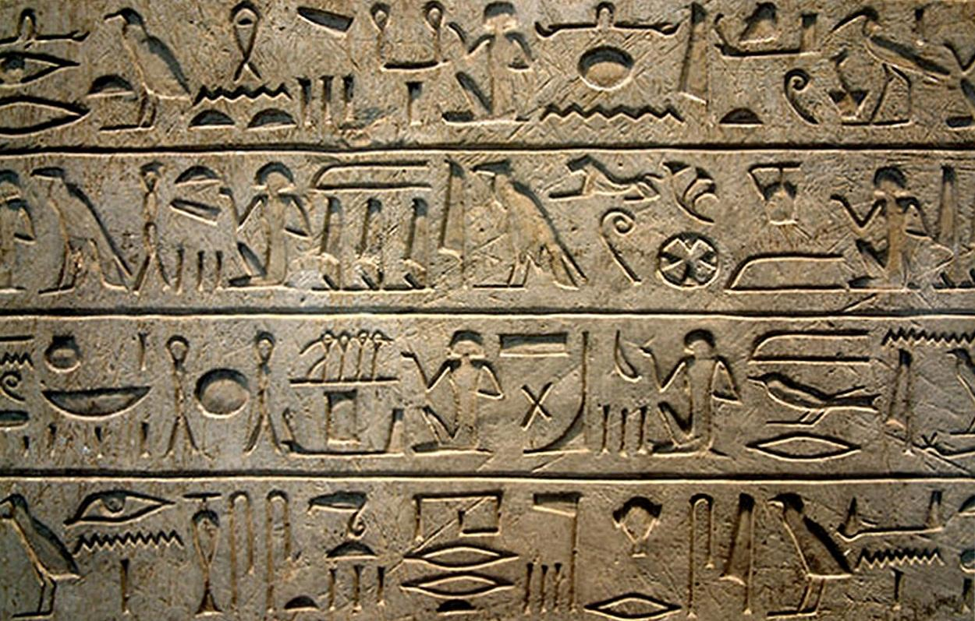
Healthy eating stars
Zucchini chips are a great alternative to potato chips and taste amazing, find a great recipe at healthykids.nsw.gov.au

Sustainability Tip
Be aware of what can be recycled at your local recycling plant. On average only 20% of what is put into recycling bins is recycled.

Culture spotlight on….
Poland boasts 17 Nobel prize winners

