Waratah All Year Care
  - Erskine Newsletter March-April 2019

Our job is child’s play

Thank you for all you support over the last year. We can’t wait to share our vison for the future with you this year

Information for families
We have officially begun our 3-year-old/Kindy program. This program is designed as a school readiness program as well as a program designed for Kindergarten children on their days off or on early finish days
Quality Improvement Plan
1.2.1 Intentional Teaching
We are endeavoring to create a more engaging program that involves all ages. We have begun conversations with the educators and children but would love some input from families
Community Event
Every Sunday, Mandurah Library hosts a storytime followed by a craft, sensory or STEAM experiences aimed at toddlers and pre-schoolers
Our reflections and focus
We have been focusing on ensuring transitions for all children are smooth and allow for children to engage with the service in a stress-free environment
Fun Fact
In 2011, The Perth Mint created a gigantic 1 million dollar coin. It broke records for both weight and value, weighing 1 tonne and worth more than $50 million dollars
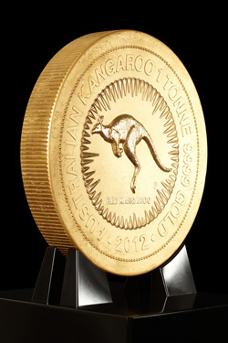
Healthy eating stars
These yummy baby corn and noodle fritters are sure to please. Find the recipe at taste.com.au

Sustainability Tip
Save money and energy with a water-efficient showerhead which uses 40% les water. Free replacements are available in parts of Australia

Culture spotlight on….
Did you know that Scotland’s national animal is a unicorn!!

